**Wireless Solar Charger**

**Project mentor**

Prabansh

**Project Heads**

Varun

Nihal

**Project Mentees**

Amogh

Fauzan

Fidha

Nisarg

Vennela

**Aim:**

To build a 10W portable, wireless solar lithium-ion battery charger. To harness maximum solar energy output, achieve MPPT(Max Power Point Tracking) and charge 8.4V lithium ion cells.

**Methodology:**

The project was divided into various blocks -

solar panel,

1.MPPT tracker and controller block

2.Transmitter block and inverter

3. Reciever block and rectifier

4. CCCV (Constant Current Constant Voltage) battery charger block.

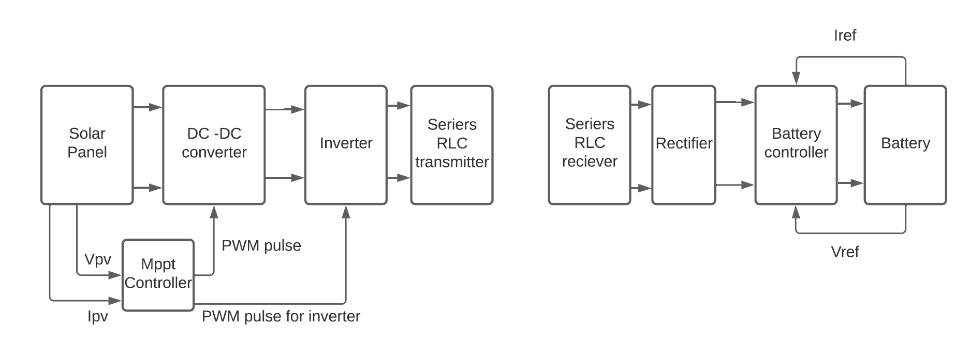

The Main Aim of this project was to build a 10 Watt Portable, Solar, Wireless Lithium Ion Charger.

To achieve this, we took the following steps:-

1. Achieve Maximum Power Point Tracking
2. Implement Wireless Transmitter and Receiver
3. Implement CCCV (Constant Current - Constant Voltage) Battery Charging

Now, for any given voltage, the solar panel will also produce a current. The amount of amps that are produced for any given voltage is determined by a graph called an **IV curve**(fig.1)

In the fig.2 above as you move along the red curve above you will find one point where the Voltage multiplied by its corresponding Current is higher than anywhere else on the curve. This is called the solar panel's Maximum Power Point**.**

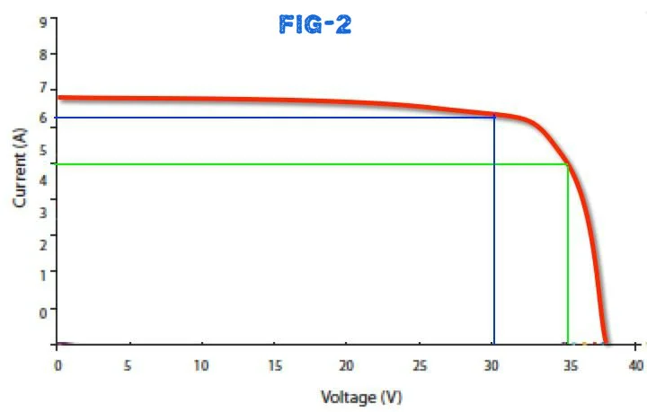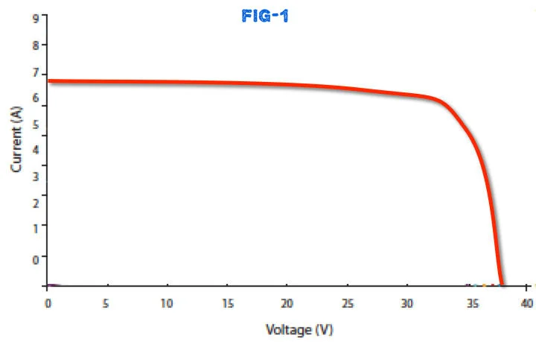

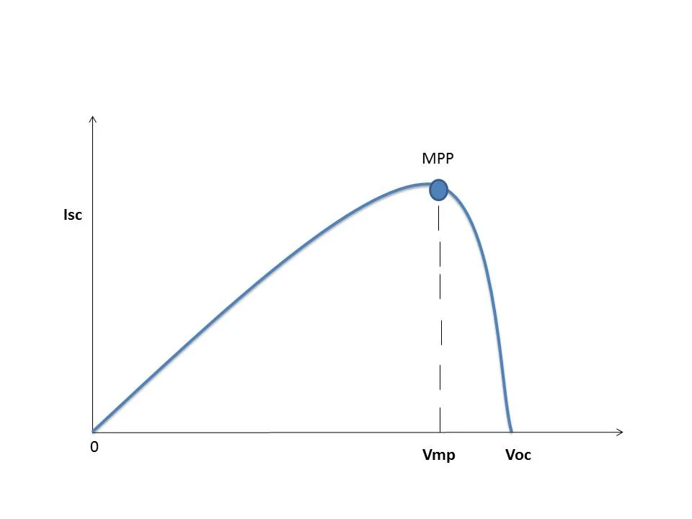

This is the reason for using an MPPT charge controller instead of a standard charge controller like PWM. The MPPT controller is consists of a DC-DC converter where the duty cycle is varied to track the Maximum Power Point.

The project was divided into various blocks - solar panel, mpp tracker and controller block, transmitter block, reciever block and finally the CCCV (Constant Current Constant Voltage) battery charger block. A 10W Solar panel of short circuit current of 0.6A and open circuit voltage of 22V was chosen. The mppt tracker was implemented using a buck converter. The microcontroller - ATMEGA328P was used to provide control signals to the MPP tracker and own signals for the transmitter.

The DC was converted to AC using an inverter and tansmission of power was achieved using a series RLC circuit. The receiver block consisted of a coil for receiving power and a rectifier in the next stage. The battery controller circuit ensures a constant charging current of 1A till the li-ion battery voltage reaches 8.4V and thereafter the battery is charged while maintaining a constant voltage of 8.4V across it.

Solar Panel

We are using a 10 Watt solar panel with mppt current of 0.7amp and 20 voltage.

MPPT Controller and buck converter

For MPPT we have used perturb and observe algorithm.We are using atmega328p for implementing algorithms.Power supply for atmega328p is provided through a 5v buck converter.We used a voltage divider for getting Solar panel voltage to atmega 328 analog pin.Used a shunt sensor with differential amplifier for measuring solar panel current and then this value is passed in form of voltage to Atmega328p to implement mppt.Those microcintroller will generate duty cycle that will control the mosfet of buck converter inorder to maintain MPP(Maximum power point at Input of solar panel).

Transmitter and inverter

Here the voltage from the buck converter is converted into pulses of frequency 20khz using a full bridge inverter.Then these pulses are passed to RLC circuit which is tuned for resonant frequency of 20kHz.At Resonant frequency we get Max power which is then transmitted wireless from transmitter inductor coil to receiver coil.

Receiver and Rectifier

We are using RLC circuit at receiver side too at resonant frequency of 20Khz to get maximum power from transmitter.Then the pulses are rectified by using a full bridge rectifier.

Battery Charge Controller

Here we are using LM317 ic which is used in constant current stage of battery charging and LM3240 ic which is uses in constant voltage stage of battery charging.This allows us to maintain lithium ion batteries at proper health by charging at different stages(Constant current and constant voltage).

**Schematics**

MPPT Controller and Current Sensor

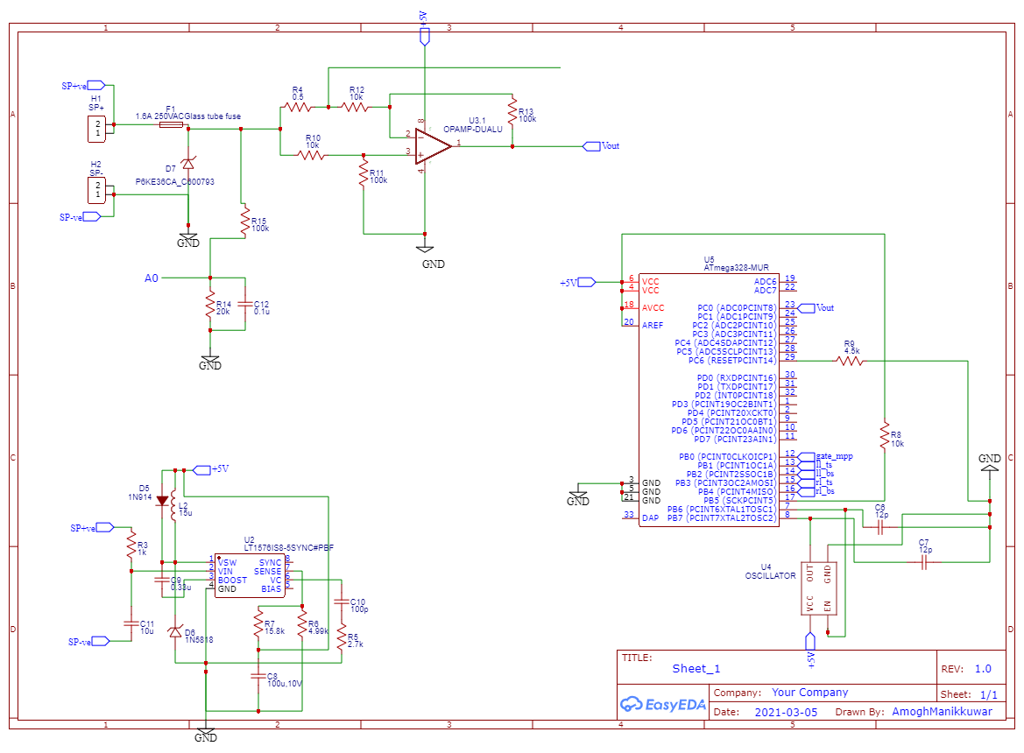

Buck Converter

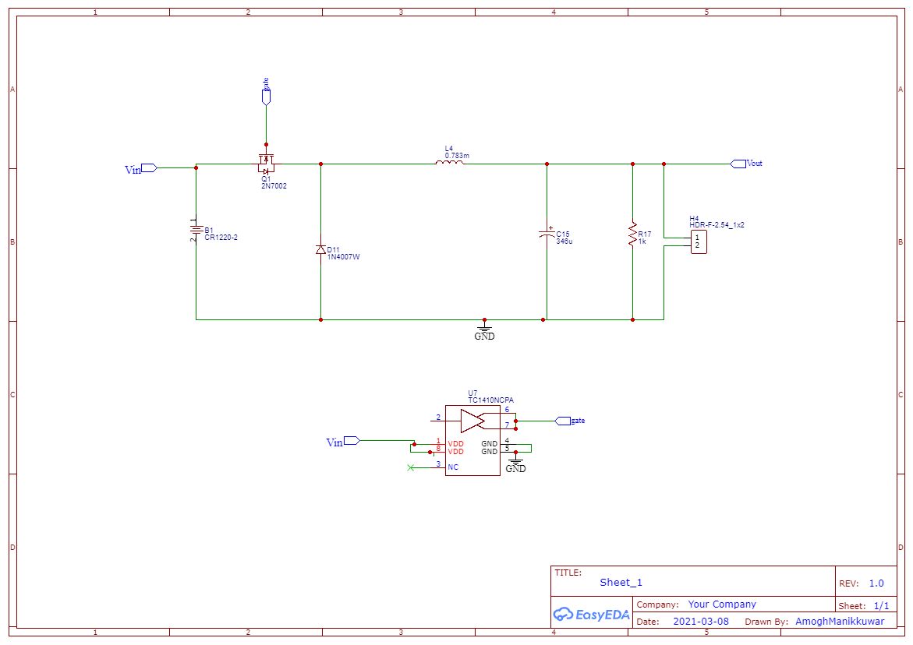

Inverter and Transmitter

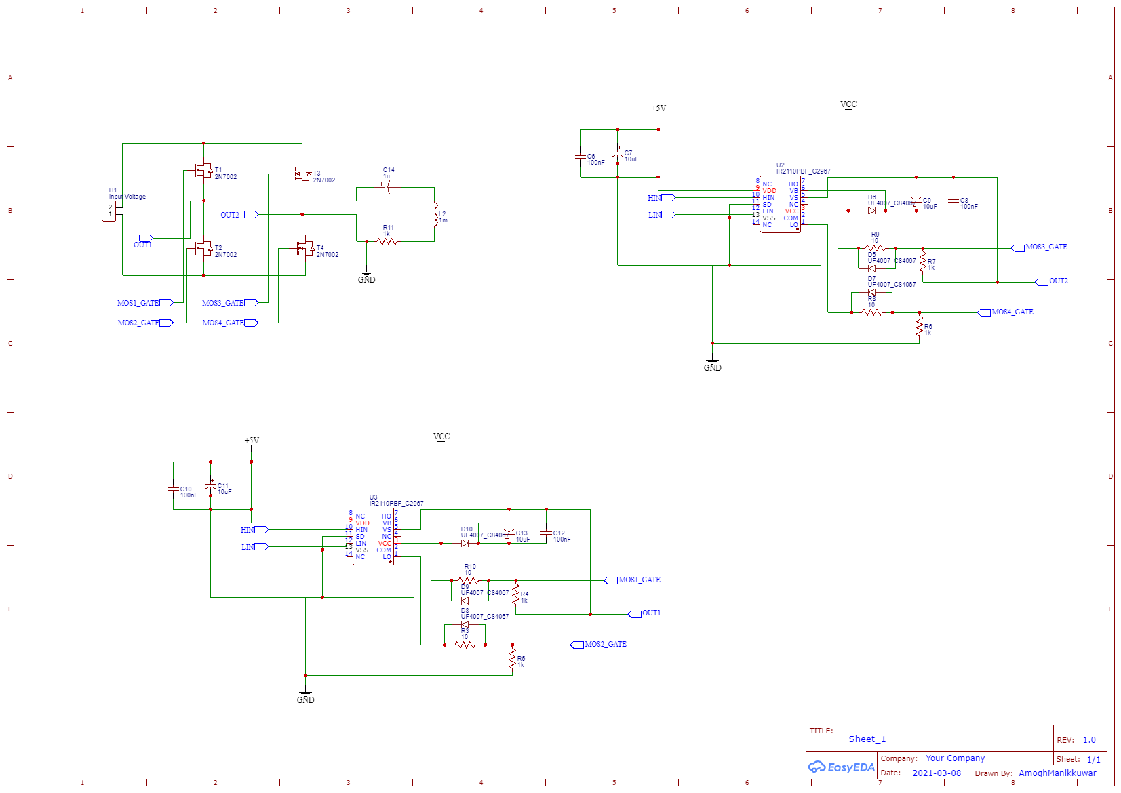

Reciever and Rectifier

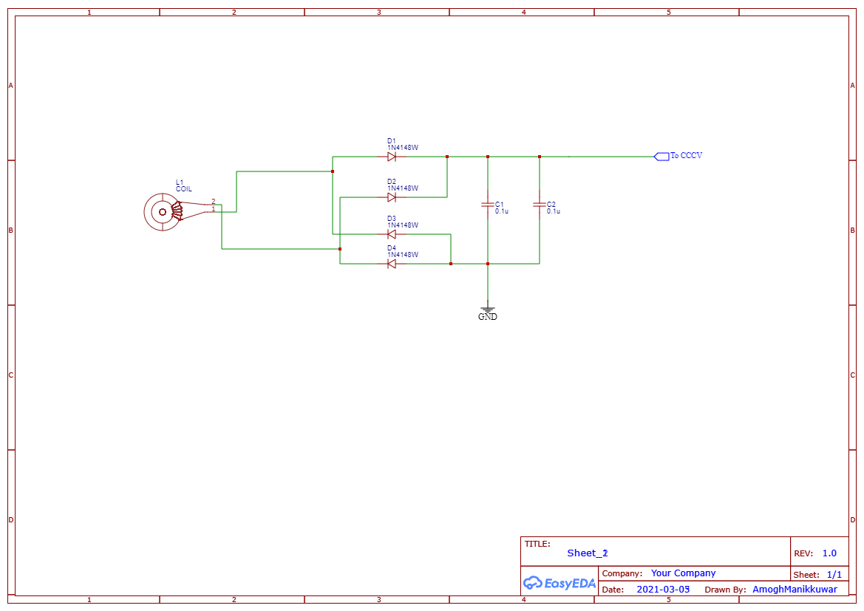

Battery Charge controller

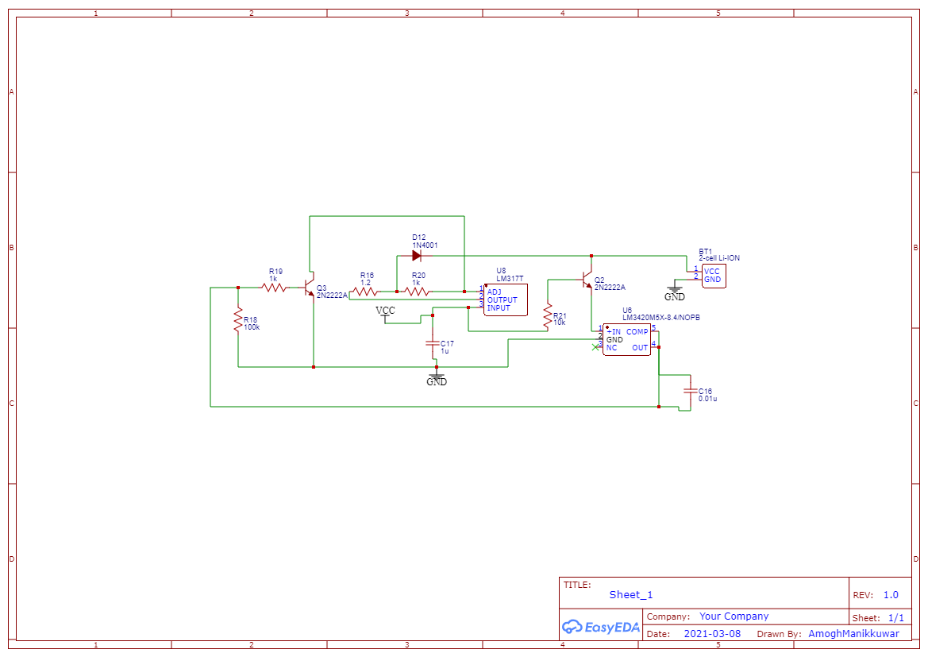

**Results and Simulations**

We performed a full Wireless solar charger model simulation in Simulink.

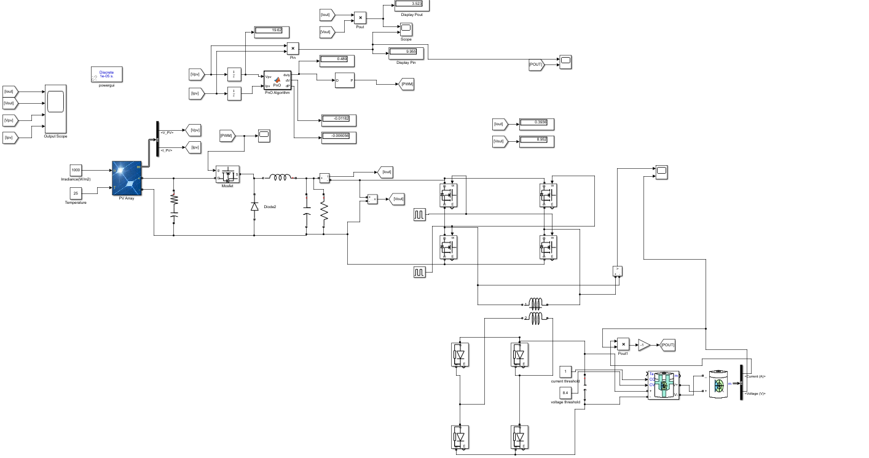

Here Yellow colour line represents the input power which slowly get saturated to 10 watt and blue colour line represents output power which saturates to 8.5 watt.

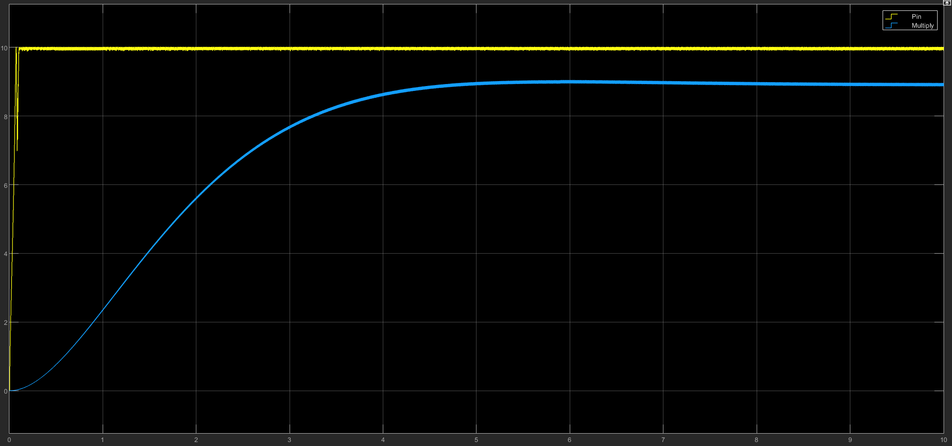

In the below figure yellow plot represents the output voltage received at receiver side which is oscillating at a frequency of 20kHz due to inverter in transmitter side.Blue line represents the output voltage of batter which is 8.4 Volt.

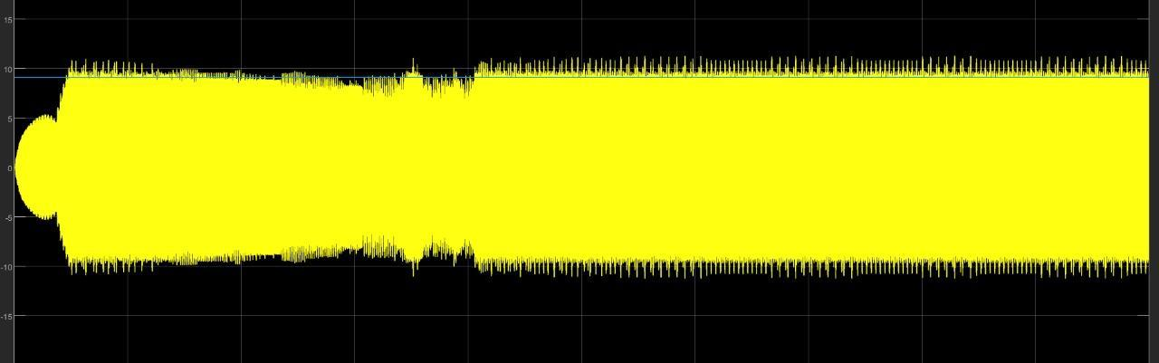

**Future Scope**

Prepare PCBs for the schematic and test the efficiency of the solar charger for different irradiance and distance between coils.